Washington Parish Council

LOCAL EMERGENCY PLAN 2025/26

PROLONGED LOSS OF POWER/SIGNIFCANT FLOODING
In the event of prolonged loss of power or significant flooding, the Washington Village Hall can be made available as a central meeting place or refuge for residents of the parish.
Address: School Lane, Washington, West Sussex, RH20 4AP.
Location
50°54’21.3″N 0°24’25.7″W 50.905924, -0.407133
what3words ///educates.ally.endings
Contact details for the Village Hall: 0774 786 0592 – Email: helentwine@wasahall.co.uk
Website address: https://washingtonvillagehall.co.uk

FLOODING
In the event that extreme weather is forecast, volunteers and members of the public should monitor weather reports and warnings by the Environment Agency to assess the likelihood of flooding.

EXTREME SNOW
In the event that extreme weather is forecast, volunteers and members of the public should monitor weather reports and warnings. West Sussex County Council are responsible for keeping roads and highways clear. Grit is provided for use by members of the public on pavements, but should not be used for private paths and driveways. Please look out for and/or call upon elderly and vulnerable neighbours to ensure that they are warm and well. When shovelling snow, please have regard for your own safety and the safety of others.

LOSS OF POWER AND/OR FALLEN TREES
Care should be taken to ensure personal safety at all times. Fallen power cables should not be approached. Only those qualified to use a chain saw should work to remove fallen trees and restore access routes.

ACCIDENT / CASUALITIES
In the event of an emergency dial 999 in the first instance. A First Responder may be the first to arrive and will bring emergency equipment with them.

Three DEFIBRILLATORS are available for use by the public in the parish:

Locations/postcodes and 'What3Words' locators can be found on the national defibrillator network for all three of our units. They can be seen here: DefibFinder - find the defibrillators nearest you.
Memorial Village Hall – on exterior wall near main entrance doors.
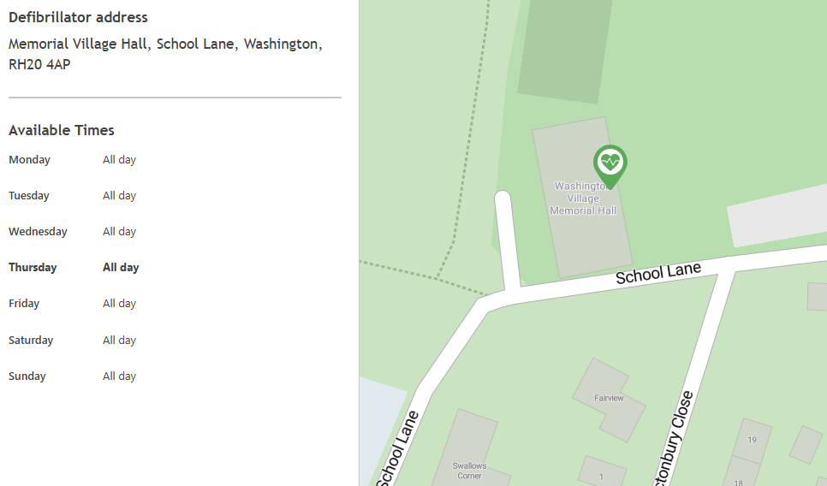

Opposite Pixies Corner (next to red postal box)
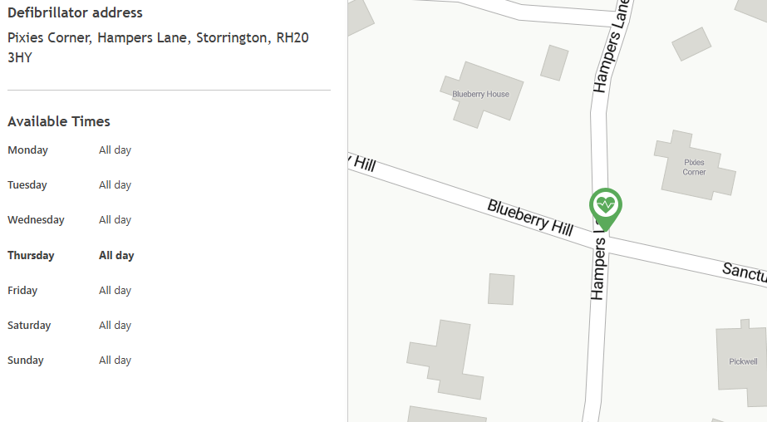

Milford Grange
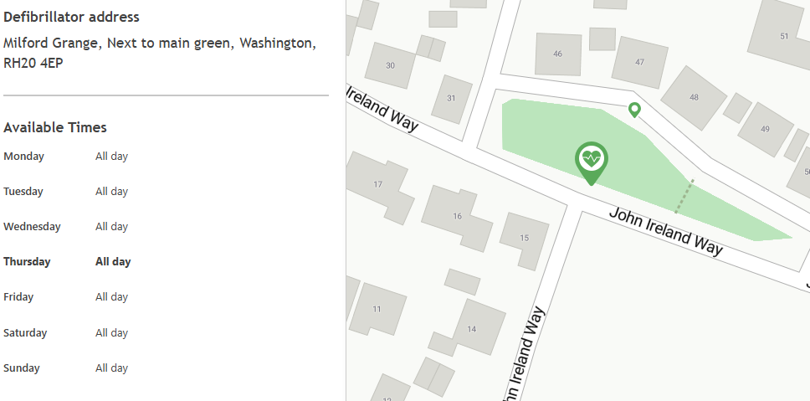

The defibrillator packs contain instructions for its use.

Care should be taken to ensure personal safety at all times. Be aware of hazards i.e.. traffic, risk of electrocution, danger of broken glass, leaking fluids, gas etc.

Emergency Contacts:

Contact during office hours/Parish Council
Mon-Thurs 9am-1pm & 2-5pm (except public holidays)
Clerk to Washington Parish Council
Tel: 0777 6771921
Email: clerk@washington-pc.gov.uk

Local Contact for Washington Parish Council
Chair of the Council Cllr Tony Lisher, Dera Doon, Georges Lane, Storrington, West Sussex RH20 3JH.
Tel: 07710 600187
Email: tony.lisher@washington-pc.gov.uk

UK Power Networks – Call 0800 3163 105 or 105 if you are in danger, notice any damage to their equipment, or are unable to use their online services.
Website and latest updates: http://www.ukpowernetworks.co.uk/internet/en/contact-us/power-cuts-and-emergencies.html

Southern Water – 0330 303 0368
Website: https://www.southernwater.co.uk/help-and-support/

Environment Agency incident hotline: 0800 80 70 60
Website: https://www.gov.uk/report-an-environmental-incident

Floodline helpline: 0345 988 1188 (7 days a week/24 hours a day)
Website: https://check-for-flooding.service.gov.uk/

National Gas Emergency Service – 0800 111 999 or textphone (minicom) on 0800 371 787
Website: https://www.nationalgas.com/emergency-contacts

Red Cross (Kent and Sussex) Provides central mobile catering facilities for communities without power.
National Helpline (General enquiries): 0344 871 11 11.
Support at Home: Tel: 0800 028 0831
Website: https://www.escis.org.uk/get-online/british-red-cross-kent-and-sussex-brcs/
Red Cross: Prepare for emergencies | British Red Cross

National emergencies - https://www.gov.uk/terrorism-national-emergency/national-emergencies

Date of review | Minute reference | Date of next review
13th May 2024 | APCM/26/14 | May 2024
12th May 2025 | APCM/25/5/20 | May 2025

West Sussex County Council Highways Authority
How you can contact us

- Online: Make an enquiry or report a problem with a road or pavement - West Sussex County Council

- For complex issues Email:
- Parish-Town.Enquiries@westsussex.gov.uk

- Phone (for issues that pose an immediate risk): 01243 642105

Social media platforms
Stay informed about road closures, severe weather alerts, and service updates: West Sussex Highways | Facebook

BlueSky@wshighways.bsky.social

WhatsApp Channel @WSHighways

West Sussex Highways (@WSHighways) / X

- Sign up to the HTP Newsletter: West Sussex County Council

- Take a look at the Severe Weather page:
Severe weather update - West Sussex County Council

